Introduction

“Live forms play their little part against a backdrop of strict regular space…
They cannot escape back into the depth of perspective. The four edges of the rectangle are absolute bounds”- Aaron Siskind

Aaron Siskind is an American photographer who pioneered abstract photography. His abstract images are famous for being set in black-and-white. Siskind hyper fixates and focuses on the details and textures of man-made surfaces like walls, sand, and graffiti. He takes his photographs from directly overhead, parallel to flat surfaces to produce a flat picture with a fresh, independent subject. This independent subject makes it singular to itself creating a disassociating feeling, making the images look lonely.

Aaron Siskind transitioned to abstract expressionism during the early 1940s. Siskind clearly took direction from the key abstract artist of the time; Mark Rothko. Action painting and colour field painting were Rothko’s two main mediums which achieved international influence. In action painting a sense of spontaneity is conveyed via the use of gestural brushstrokes, each brush stroke is his personal choice to express himself. The abstract expressionist artists communicate their refined interests in the aesthetics of their speculative, abstract art. Siskind clearly took the idea of aesthetics into his own work, seen through his choice to isolate objects in tight, clean framings. Siskind and Rothko share are the ability to see the many connections their pieces create and they’re both able to see the relationships they’ve built with their pieces, due to their personal involvements. Even so they know the piece is one itself and capture that within the four boarders of a frame.

I will be finding the meaning of abstraction within Siskind’s photographs by investigating his transition into abstract expressionism.

Aaron Siskind. Gloucester. 1944.

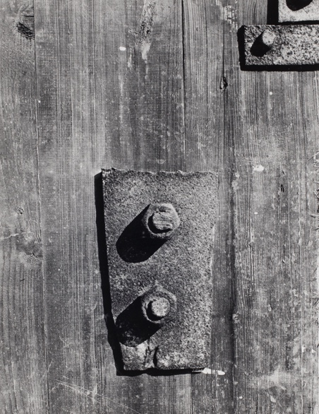
Gloucester was photographed in Gloucester, Massecuites in 1944, by Aaron Siskind an American photographer. Siskind was influenced by the abstract expressionist painters of the 1940’s. Since Siskind welcomed abstract explanations the Gloucester series is noted for its move towards abstraction. His up-close, perspective, style disguises the identity of the object allowing for more metaphorical interpretations. In 1930, Aaron Siskind was a part of the radical, political group- the New York Photo League; this group dedicated photographs to make social and political comment to promote social change. An example of his work (from this time) is the Harlem Document; a photo essay that educated viewers on the conditions the community was living in. At this time, he also produced work on the issues with the Catholic Worker Movement and the general urban environment. However the Gloucester series marked Siskind’s shift from documentary to abstract photography, this helped him establish his reputation as a leading figure in abstract photography.

Siskind’s subject matter (in the Gloucester series) was based on direct observation, meaning this series consisted of used objects from the fishing village, such as weathered wood, tar paper and any found surfaces. From the objects he chose, he designed compositions of significance to him. The objects he chose often reflected his emotional state at the time, he chose some objects simply because they interested him, things like rope, seaweed and footprints in the sand. Similarly, to how Siskind chose his objects, I chose to discuss Gloucester as it appealed to my eyes, naturally.

The two dominant tones are light and dark grey; these tones work well together and merge effortlessly leaving a smooth look. As the screws are placed just below the centre of the image, a dark, black, shadow appears. The shadow points on a diagonal, down to the left corner of the image where there’s only a wooden panel to be seen. In comparison to the top right corner which is busier with a screw and two pieces of metal which works well because of the minimal uses of black. Although the photograph isn’t equilateral or symmetrical it is full of texture. There are lots of different shapes within the photograph. In the centre there’s a metal rectangle with circular bolts screwed into it. In the top right corner of the image there’s a smaller metal rectangle which contains a small, circular, screw. The assorted shapes create a feeling of disorder. Although the photograph isn’t equilateral or symmetrical it is full of texture. Theres texture in-between the wood, and where the metal has rusted becoming jagged and sharp.

Overall, Gloucester leaves me feeling serene. Since the shapes used are the same and only diverse within the way they’ve been turned and placed, I find the deviation in shapes and layout contradictory but fitting. The general colour scheme is cohesive as it complements the shadows well due to the minimal but effective use of black.

Aaron Siskind. Chicago One. 1949.
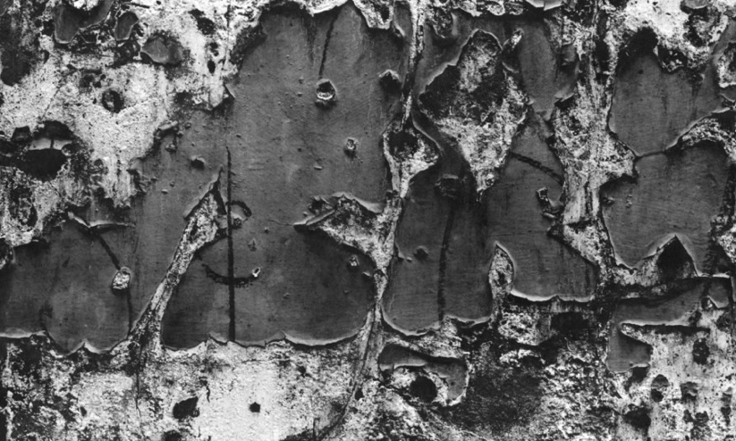
Aaron Siskind’s Chicago One was photographed in Chicago, in 1949. Chicago One is held in several major museums such as the Art Institute of Chicago and Whitney Museum of American Art. The picture is from a series of photographs Siskind took in-between the late 1940s and 1950s. Siskind took the images in urban and natural environments, to express himself artistically- like an abstract expressionist painter.
Chicago One is a gelatine silver print taken from a flattened perspective which allowed for no distractions. The tones made are predominately dark grey and black with minimal features of white/ light grey highlights. I find these tones alluring and aesthetically pleasing due to them combining agreeably.
Siskind’s work in this period was in similitude with the abstract expressionist movement as he aimed to achieve homogeneous emotional profundity. He wanted to depict “inner drama” and intramural feelings by a recording medium. He was influenced by painters like Franz Kline, Mark Rothko, and Willem de Kooning (his friends at the time). As the dominant art form of the time was abstract expressionism, Siskind followed the popular style, as this piece is abstract. Siskind captured graphic patterns and forms, as Chicago 1 went beyond liberal representation as it focused on the graphic qualities of the paint peeling from the wall, pioneering abstract photography further as it encouraged the viewers to feel subjectively towards the piece.
Siskind said “I accept the flat plane of the pictures surface as the primary frame of reference of the picture”. This is Siskind saying he is at peace with the overall outcome being brought to life by the flat image. Due to the up-close nature of the image and the use of extreme cropping, the rough textures of the wall are highlighted to maintain the abstract feel. To develop a unique composition a frontal viewpoint is used with a shallow depth of field.
The key points where the paint has peeled are left and right of the centre. Where the paint has become stripped, interesting, shaped holes formed. The piece is of great visual relevance causing my eyes to be drawn to the textures in the paint as the small details look, to me, like mountains being photographed from above causing for internal questioning of what the image is truly about or of.

Aaron Siskind. Rome 5. 1967.
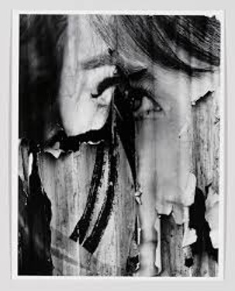
The 1960s was a period of significant change. New radical styles characterised common art forms. In the 1960’s, breaking away from the traditional arts began gaining traction. Siskind challenged the common notions of photography whilst following the shifting values of the era. His techniques included shooting crumbling walls, graffiti, and natural formations. He emphasized elements like line, texture, and shape to challenge the traditional notions of what photography was. During 1967, Aaron Siskind worked in Rome, he created the series “The Arch of Constantine”, in which Rome 5 featured. The series focused on the textures produced from decay he witnessed in Rome. Multiple versions of Rome 5 exist in several major museums, including the Metropolitan Museum of Art, The National Gallery of Art, and The Whitney Museum of American Art.

Aaron Siskind’s intention was to induce the feeling of tension, he did this by focusing on the decay of mundane man-made surfaces. This surface was left with marks and teres leaving it to look messy and chaotic. Due to the uncertainty of decay being contrasted by the slickly, famed photograph, a feeling of tension builds between order and precariousness. Photographed vertically, Siskind resolved the tension by framing the image, making the final picture, overall timeless.

“An altogether new object, complete and self-contained, whose basic condition is order”- Aaron Siskind

Gelatine silver print is the most common method for black and white photography, and it was the medium Siskind chose to use. A light-sensitive emulsion of silver halides coats the paper. The image is projected onto the paper, which is next exposed to light, creating an invisible image. A series of chemical baths reveal the latent image. To remove excess silver a stop bath takes place and a fixer makes the image permanent. Finally, to complete the print the chemicals are washed away.

Aaron Siskind’s, Rome 5 employed a black, white and grey colour scheme which blends harmoniously. I think Siskind’s sharp uses of black points are vivid and effective due to the piece being predominately grey.

A large, chunky rip reaches the singular curved, eye placed in the centre of the photograph. The large tare and peeling paint contrast nicely against the soft water marks which have darkened from the weather overtime. The torn surface shows the varying texture in the piece which I find to be a pleasing, diverse composition. The unparalleled composition can root the start of an internal, emotional drama. On a psychological level, viewers may become emotional when looking at this image, if they internally relate or resonate with the piece.

Aaron Siskind took photographs by focusing on the formal and abstract qualities of subjects. He did this by closing in on subjects, framing out distractions, and isolating expressive forms in both natural and man-made environments. Overall, I think Rome 5 holds together an eye-catching entity. As the up-close photograph focuses entirely upon the eye capturing the emotional and metaphorical powers which textures and shapes hold.

"There is only the drama of the objects, and you, watching”-Aaron Siskind
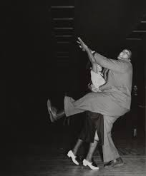
Conclusion
When I was trying to find the meaning of abstraction within Siskind’s photographs, I investigated his transition into abstract expressionism. His career started with social documentaries in the 1930s. An example of his work from the 1930’s is his photograph of Savoy Dancers from the series Harlem Document, 1936. This image focused on two dancers in the Savoy Ballroom, mid-movement. The duo looks truly happy as they’re wide smiles are captured perfectly. The man has one leg lifted in the air with his other leg planted on the floor as his partners feet are slightly lifted. The man is also lifting his and his partners hands in the air. In 1940, Siskind began realising his great interest lied with abstract expressionism, starting with his Gloucester series which allowed him to progress further into contempered art. There was a large change at this time because of the aftershocks of World War II. As the art world grew massively, it’s eyes were opened to the new, diverse ideas people took from the war. There was a rise in Abstract Expressionism in America and a rise in Social Realism globally. Siskind set about finding objects that fascinated him or engaged him emotionally. In the Gloucester series, Siskind chose objects based of how they made him feel, be it they made him feel sentimental, content or stirred. Siskind chose them due to an internal urge that can only be captured by him; he shows this to the world through his choices of framing which emulate different feelings for each viewer.
“Photography is a way of feeling, of touching, of loving. What you have caught on film is captured forever... It remembers little things, long after you have forgotten everything.”- Aaron Siskind
Bibliography
Word count: 1932
Books-
- Aaron Siskind: Photographs, 1932-1978 by Aaron Siskind
- Interior Drama: Aaron Siskind’s Photographs of the 1940’s by Aaron Siskind
- Places, Nineteen Sixty-Six to Nineteen Seventy- Five Photographs by Aaron Siskind
- The Drama of Objects by Aaron Siskind
Websites-
- https://www.moma.org/artists/5456-aaron-siskind
- https://www.artic.edu/artworks/94284/gloucester
- https://whitney.org/artists/3581
- https://brucesilverstein.com/artists/34-aaron-siskind/
- https://www.moca.org/collection/work/chicago-1
- https://www.artic.edu/artworks/119185/chicago-1
- https://whitney.org/collection/works/19952
- https://www.artnet.com/artists/aaron-siskind/rome-5-OLRiWQHMY5autr40NWdCrQ2
- https://www. https://smartmuseum.uchicago.edu/about/publications/photographs-by-aaron-siskind-in-homage-to-franz-kline/ artsy.net/artist/aaron-siskind
- https://smartmuseum.uchicago.edu/about/publications/photographs-by-aaron-siskind-in-homage-to-franz-kline/
- https://www.theartstory.org/artist/siskind-aaron/
- https://www.takaishiigallery.com/en/archives/23257/

